Case Study

The controversy of Dow Sponsorship
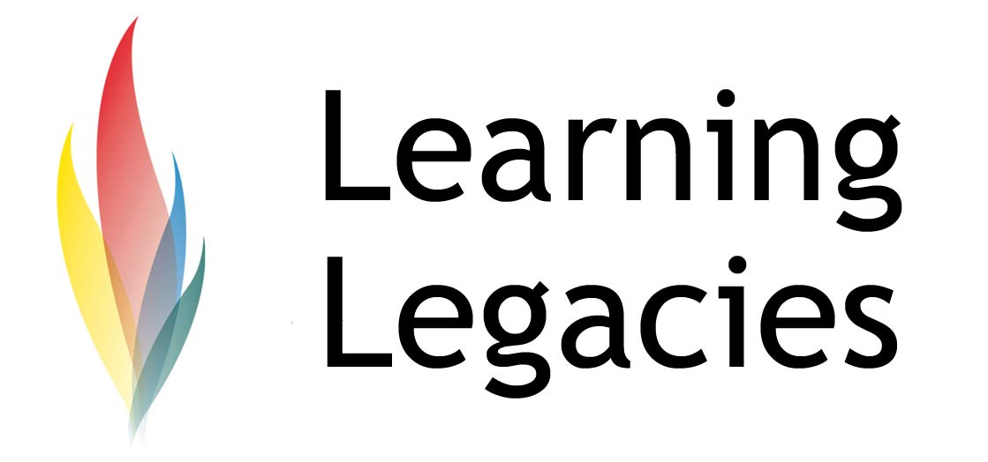
The Olympic Games are considered to be one of the most effective international marketing platforms in the world. When Summer 2012 arrives, the globe will tune in to Games coverage on TV, via the Internet or radio, and a few lucky thousand people will attend the Games in person. The power of the brand, the sport and the streamlined coverage of the spectacle around the globe allow the Olympic and Paralympic Games to reach literally billions of people in over 200 countries and territories throughout the world. The value of the Olympic brand is accentuated by the possibility of history being made at any time – via world records, stunning athletic performances, unforgettable opening and closing ceremonies, the strength and power of the athletes and camaraderie amongst teams.

Inevitably, the Games have become an incredible draw for companies wishing to sponsor the Games, so that they can also benefit from the magic and global reach of the Games. Private sector investment is also crucial to the Olympic Movement in order to be able to sustain the monumental level of organisation and staging that the Games require. Currently, revenue generated by commercial partnerships accounts for more than 40% of Olympic revenues. Olympic partners also provide vital technical services and product support.

Because sponsorship of the Games has become so popular, the IOC have developed a sponsorship programme that includes specific sponsorship categories, defined by geographic region, and which notably limits the number of sponsorship contracts available (a vital step in securing the viability and high cost/desirability of attainment of Olympic sponsor status). The partner programme is officially known as the TOP Partner Programme. Worldwide sponsors include Coca-Cola, Acer, Atos, Dow Chemical, GE, McDonalds, Omega, Panasonic, Proctor & Gamble, Samsung, and Visa, in addition to a range of domestic sponsors.

Controversy of DOW Sponsorship
The awarding of TOP Partner status to Dow Chemical (a 10-year agreement) has raised a particularly high level of consternation in India. Whilst criticisms exist over the choice of other sponsors, such as the worldwide sponsor McDonald’s (due to health concerns), and Cadbury, one of the domestic sponsors of the London 2012 Games (for the same reason), the controversy that has arisen over Dow Chemical may well prove the most acrimonious. The role of Dow Chemical is to produce a sustainable fabric (‘wrap’), worth £7 million, that will cover the Olympic stadium and enable digital images to be shown. Dow Chemical have also provided funding to the tune of $11.4 million for artwork.

Reasons for the Controversy
The basis controversy is clear. In 1999, Dow Chemical purchased another company - Union Carbide. Union Carbide was responsible for running a plant in India when, in 1984, as many as 25,000 Indian workers died as a result of a gas leak at the plant. Campaigners planned protests in Bhopal, New Delhi and London, and officially lobbied the Indian Government to make an official protest against the decision of LOCOG to engage in a partnership deal with Dow. Protestors felts that the Olympic sponsorship deal legitimised the company’s controversial links to Union Carbide. LOCOG responses by issuing a statement that Dow Chemical did not own the company at the time and therefore had no culpability.

Activists such as Greenpeace feel that Dow Chemical has not addressed their responsibilities in a sufficient matter and should therefore not be associated with the Olympics. They cite evidence from the Indian Government that cited the death of 3,500 people in the days following the leak, a further 15,000 death since that time, and the possibility of a death toll as high as 25,000 as the environmental fall out continues to this day. The Indian government says some 3,500 people died within days of the leak. The deaths led to a total settlement worth £288million.

A Response from Dow Chemical
Dow Chemical responded to criticisms by explaining that they had never owned nor operated the plant where the gas leak occurred, and had acquired the plant a long time after the legal claims surrounding the incident were resolved. They also indicated that they, and their competitors, had learnt valuable lessons from the incident and had invested in significant improvements to their operations in order to ensure that such a disaster would never occur again.

The controversy of Dow Sponsorship
Amnesty International has also protested against the decision, citing their belief that the £288million settlement did not, in fact, represent the true scale of the disaster, that the choice of Dow would distress victims of the disaster, and that the company had not yet sufficiently investigated the human rights abuses that occurred as a result of the tragedy. Indeed, the Indian Government has since lodged a fresh demand for a further $1.1 billion in compensation from Dow Chemical as a result. Detractors do not feel that the choice of Dow Chemical represents a commitment by the IOC to the sustainable sourcing guidelines and principles cited in their own guidelines.

Further Information
- Olympic Sustainable Sourcing Guidelines ,June2011: http://big.assets.huffingtonpost.com/olympiccode.pdf
- Dow Chemical Corporate Website
www.dow.com
- Dow: A Chemical Company on the Global Playground
http://dowethics.com/
- Ferkins, L. (2009) Board Involvement in Strategy: Advancing the Governance of Sport Organizations Journal of Sport Management, 2009, 23, 245-277

- Bebchuk, L. Cohen, A. (2009) What Matters in Corporate Governance? Review of Financial Studies, 2009 – Society of Financial Studies

Discussion

Case Study

The controversy of Dow Sponsorship

WOMENS PARTICIPATION IN THE OLYMPIC GAMES
- Do you feel that association of the Olympic Games with controversial corporations has the potential to harm the Olympic brand?
- If yes, what evasive action might you take if you were on the IOC board, in charge of the

Case Study

WOMENS PARTICIPATION IN THE OLYMPIC GAMES
Top Partner Programme?
- What corporate governance issues does this Discussion Starter raise, in terms of issues of responsibility, accountability & legality?

This resource was produced as part of the 2012 Learning Legacies Project managed by the HEA

Case Study

WOMENS PARTICIPATION IN THE OLYMPIC GAMES
Hospitality, Leisure, Sport and Tourism Subject Centre at Oxford Brookes University and was released

Case Study

The controversy of Dow Sponsorship

WOMENS PARTICIPATION IN THE OLYMPIC GAMES
as an Open Educational Resource. The project was funded by HEFCE and part of the JISC/HE Academy UKOER programme. Except where otherwise noted above and below, this work is released under a Creative Commons Attribution only licence.

Exceptions to the Licence
The name of Oxford Brookes University and the Oxford Brookes University logo are the name and registered marks of Oxford Brookes University. To the fullest extent permitted by law Oxford Brookes University reserves all its rights in its name and marks, which may not be used except with its written permission. The JISC logo is licensed under the terms of the Creative Commons Attribution-Non-Commercial-No Derivative Works 2.0 UK: England & Wales Licence. All reproductions must comply with the terms of that licence.

The Higher Education Academy logo is owned by the Higher Education Academy Limited and may be freely distributed and copied for educational purposes only, provided that appropriate acknowledgement is given to the Higher Education Academy as the copyright holder and original publisher.

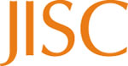

Reusing this work
To refer to or reuse parts of this work please include the copyright notice above including the serial number. The only exception is if you intend to only reuse a part of the work with its own specific copyright notice, in which case cite that.

If you create a new piece of work based on the original (at least in part), it will help other users to find your work if you modify and reuse this serial number. When you reuse this work, edit the serial number by choosing 3 letters to start (your initials or institutional code are good examples), change the date section (between the colons) to your creation date in ddmmyy format and retain the last 5 digits from the original serial number. Make the new serial number your copyright declaration or add it to an existing one, e.g. ‘abc:101011:011cs’.

If you create a new piece of work or do not wish to link a new work with any existing materials contained within, a new code should be created. Choose your own 3-letter code, add the creation date and search as below on Google with a plus sign at the start, e.g. ‘+tom:030504’. If nothing comes back citing this code then add a new 5-letter code of your choice to the end, e.g.; ‘:01lex’, and do a final search for the whole code. If the search returns a positive result, make up a new 5-letter code and try again. Add the new code your copyright declaration or add it to an existing one.

